***EPROJECT***

|  |  |  |
| --- | --- | --- |
| ***S.NO*** | ***NAME*** | ***ENROLLMENT NO*** |
| **1.** | Atta-e-Rabi | Student1469831 |
| ***2.*** | Huzaifa Farooqui | Student1422396 |
| ***3.*** | Hassan Saalim | Student1484183 |
| ***4*** | Abdullah Asghar | Student1473694 |

***E-VACCINATION MANAGEMENT SYSTEM FOR CHILDREN***

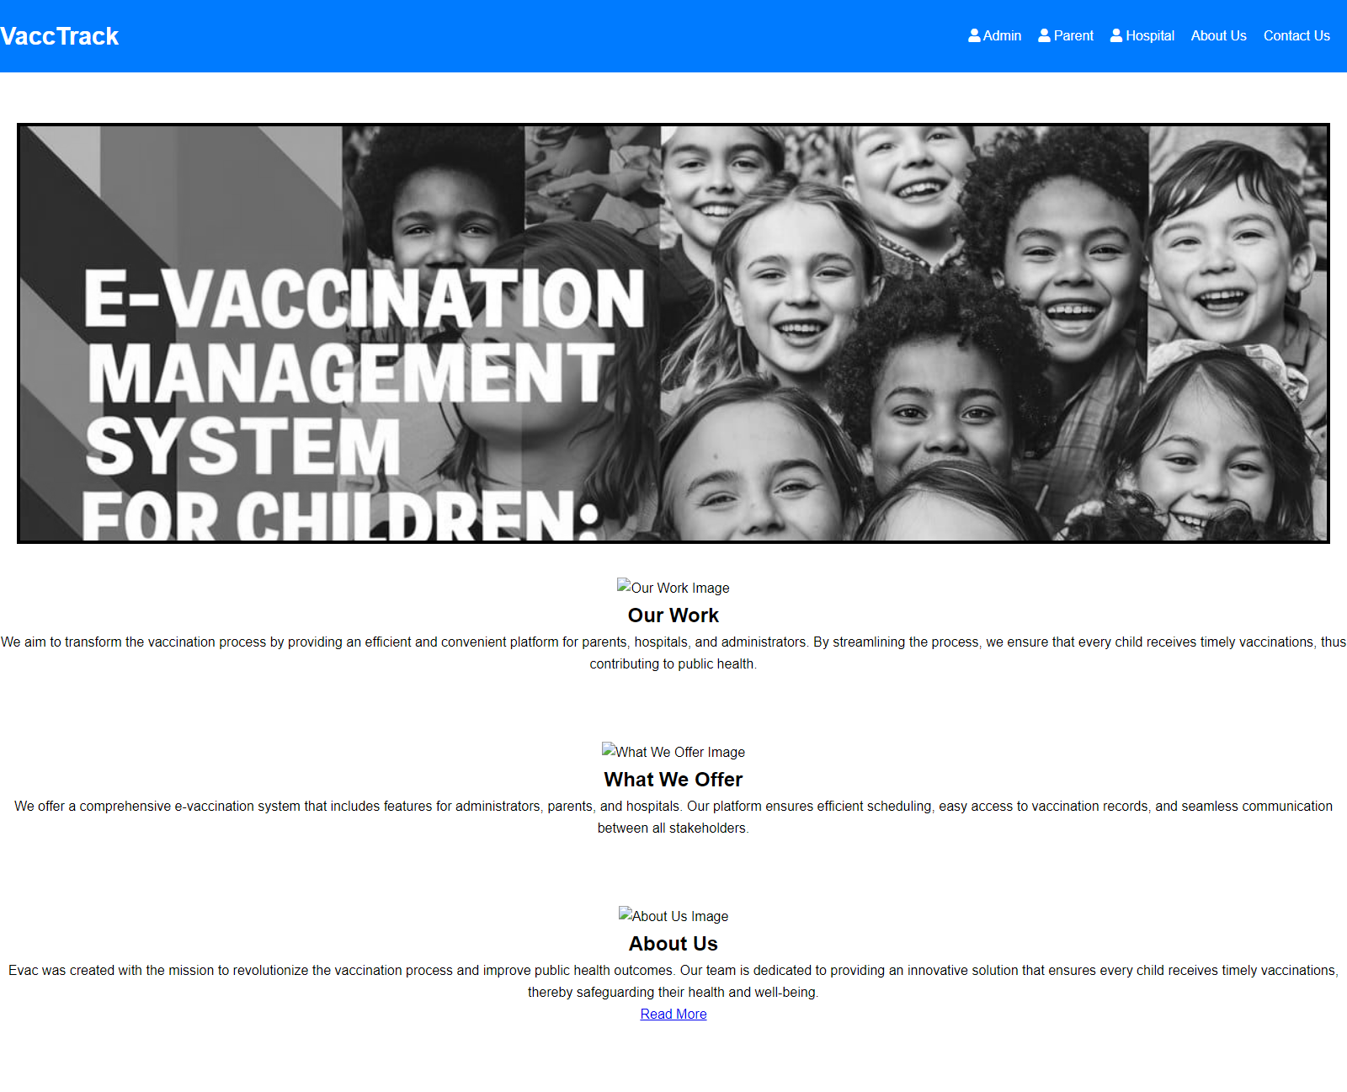

**VaccTrack Website User Guide**

This user guide will walk you through the VaccTrack website, a platform designed to streamline the vaccination process for parents, hospitals, and administrators.

**Getting Started**

* Open a web browser and navigate to the VaccTrack website.

**Website Layout**

The website is divided into three main sections:

* **Header:** The header section contains the website logo, navigation bar, and login links for different user types (Admin, Parent, Hospital).
* **Main Content:** The main content section displays information about VaccTrack's services, including:
  + **Our Work:** This section explains VaccTrack's mission to transform the vaccination process and ensure timely vaccinations for all children.
  + **What We Offer:** This section details VaccTrack's comprehensive e-vaccination system features for administrators, parents, and hospitals.
  + **About Us:** This section provides information about Evac, the team behind VaccTrack, and their dedication to improving public health outcomes through vaccination.
* **Footer:** The footer section may contain additional information or links that are not relevant to the main content of the webpage.

**Navigation**

* The navigation bar located in the header section provides links to different pages on the website, such as About Us and Contact Us (although these links are not functional in the provided code).

**Content Sections**

* Each content section (Our Work, What We Offer, About Us) includes an image and a text description.
* The "About Us" section also includes a "Read More" button that might link to a more detailed page about Evac, the creators of VaccTrack (this link is not functional in the provided code).

**Functionality**

* The provided code includes some basic Javascript functionality that redirects users who click on the "Admin" or "Parent" links in the navigation bar to separate login pages (these pages are not included in the provided code).

**Additional Notes**

* The website is still under development, as evidenced by non-functional links and a placeholder image in the Hero section.
* The website uses responsive design principles to ensure an optimal viewing experience on different devices (desktop, mobile, tablet).

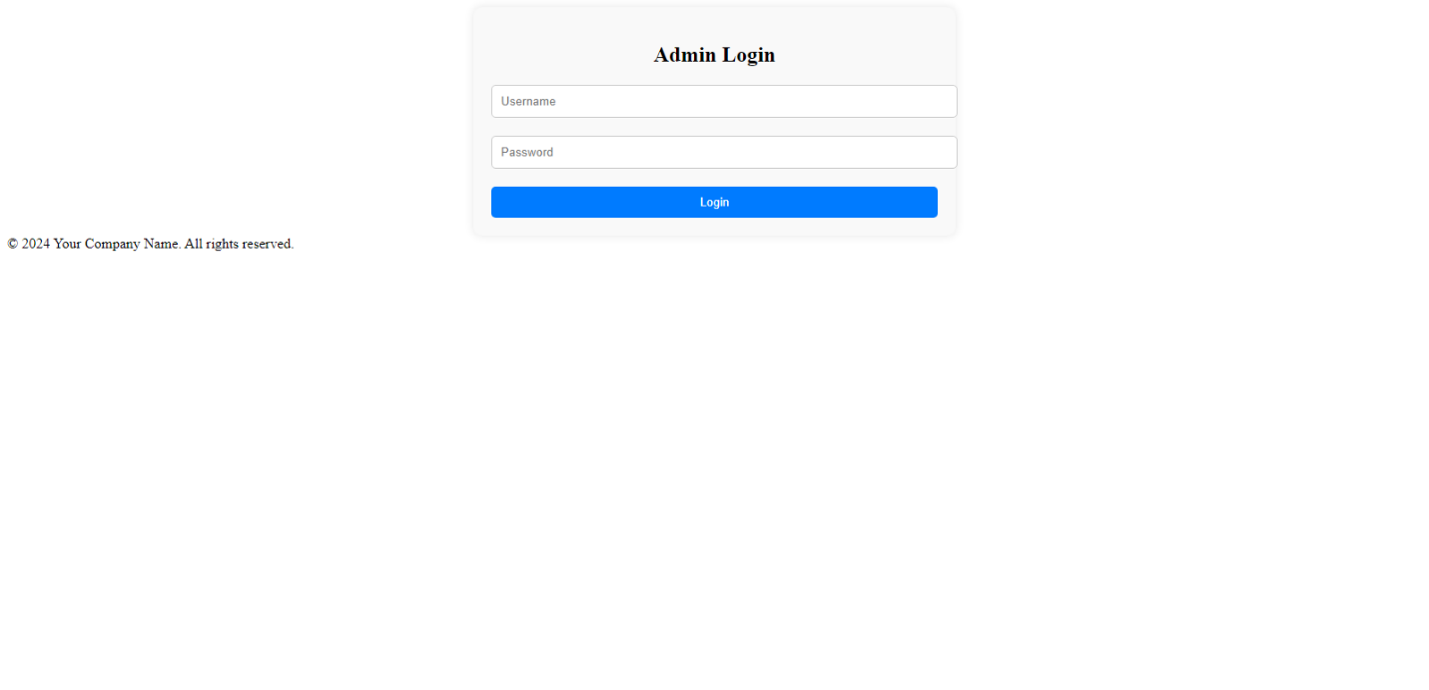

**Admin Login Page User Guide**

This user guide explains how to log in to the admin section of a website. The login page likely belongs to a Content Management System (CMS) used to edit and update the website content.

**Logging In**

1. Open a web browser and navigate to the login page of the website's CMS. The login page URL might not be publicly accessible and may only be available to authorized users.
2. On the login page, enter your username in the username field.
3. Enter your password in the password field.
4. Click the "Login" button.

**Username and Password**

* The username and password required to log in are created by the website administrator. If you are not the website administrator, you will not have the necessary login credentials.
* For security reasons, it is recommended that you do not share your login credentials with anyone.

**Successful Login**

* If you entered the correct username and password, you will be redirected to the admin panel of the website's CMS.

**Unsuccessful Login**

* If you entered an incorrect username or password, you will see an error message on the login page. Double-check that you are entering the login credentials correctly and try logging in again.

**Forgot Password**

* If you have forgotten your password, you may not be able to recover it using this login page. You will likely need to contact the website administrator to reset your password.

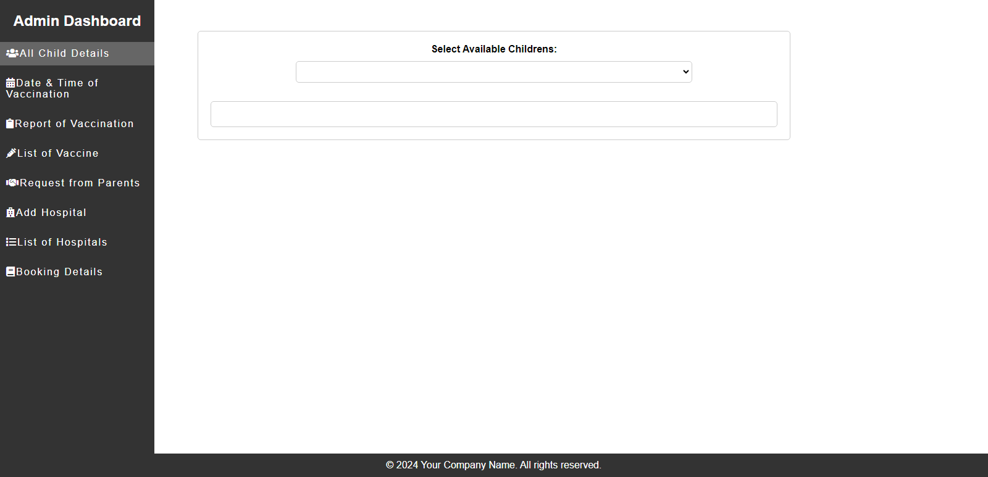

***ADMIN DASHBOARD***

• Navigate to the "All Child Details" section of the admin dashboard. This section is likely highlighted in the sidebar menu.

• Locate the dropdown menu labeled "Select Available Children." It is positioned under the label "Select Available Childrens:" within the content section.

• Click on the dropdown menu to view the list of children.

• Select a child from the list by clicking on their name.

• Once a child is selected, their details will be displayed in the section below the dropdown menu. This section is identified by the div tag with id "child Details".

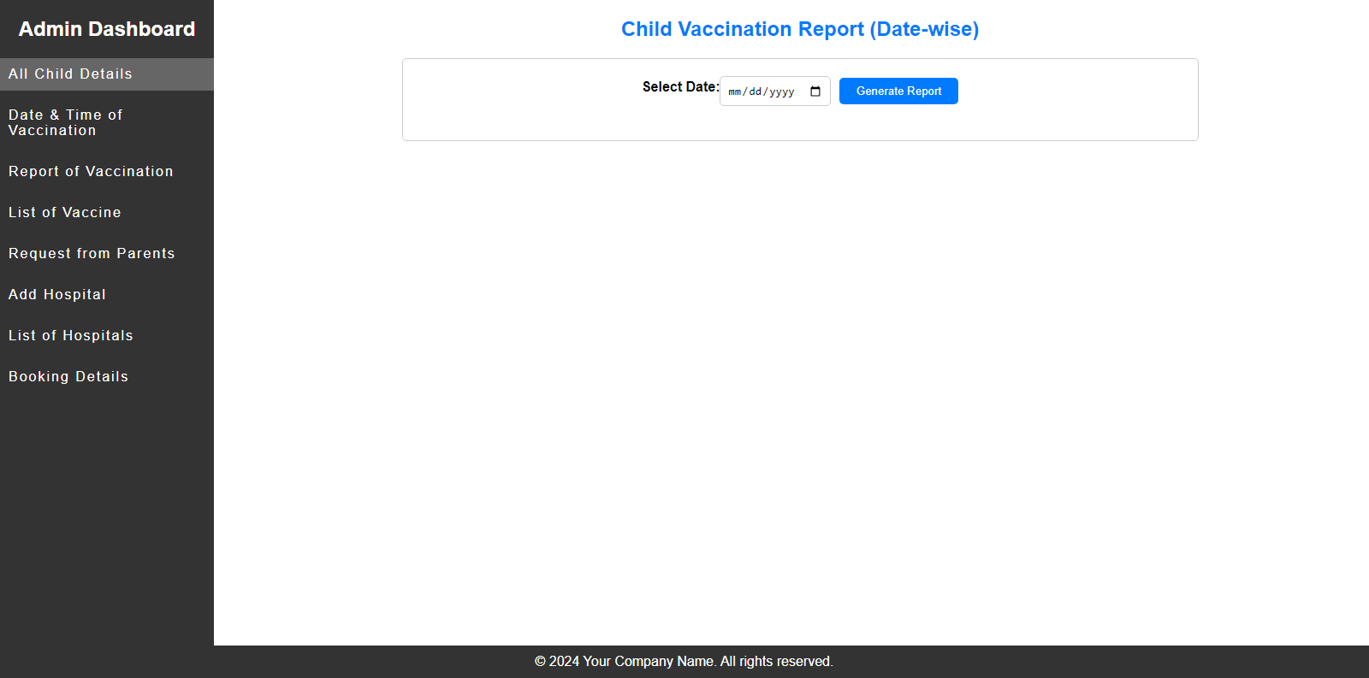

**This webpage is part of an admin dashboard for managing child vaccinations. This section allows admins to generate reports on child vaccinations for a specific date.**

**Here's how to use the webpage:**

1. **Navigate to the "Report of Vaccination" section:**
   * Look for the sidebar menu on the left-hand side of the webpage.
   * Click on the option labeled "Report of Vaccination".
2. **Select a Date:**
   * In the "Child Vaccination Report (Date-wise)" section, locate the form with the label "Select Date:".
   * Click on the date picker input field.
   * Use the calendar to select the date for which you want to generate the vaccination report.
3. **Generate Report:**
   * Once you've selected a date, click on the button labeled "Generate Report". This button is located next to the date picker input field.
4. **View Report:**
   * If there are vaccination records for the selected date, a table will be displayed below the form. This table will show the "Child Name," "Vaccine Name," and "Vaccination Date" for each child vaccinated on that date.
   * If there are no vaccination records found for the selected date, a message will be displayed indicating that no records were found.

**PARENT DASHBOARD**

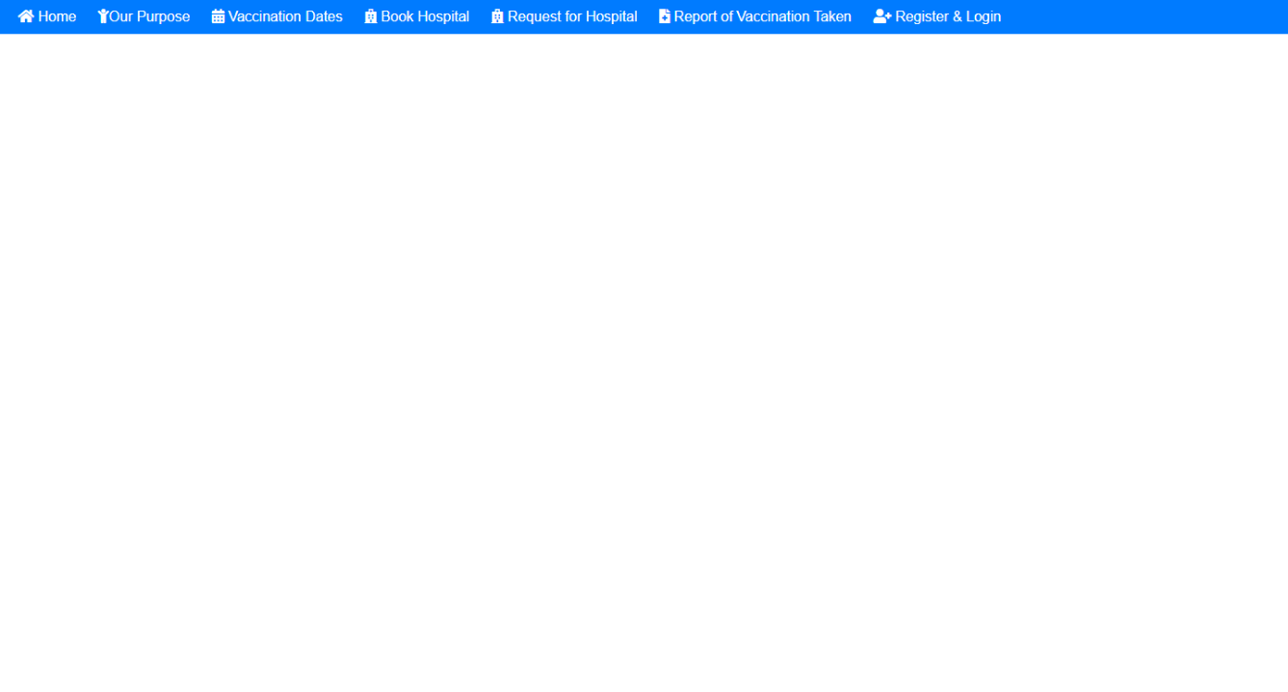

If the parent wants to vaccination for their child then the parents register & login.

If the parents wants to register & login then they move on register & login page.

**Register & login:**

For registeration the parents full the form.

In the form parent write a full name, email & password.